The African Lovebird Society of Australia Incorporated

Thank you for considering becoming a member of our African Lovebird Society.

As a Member you will receive all the entitlements of the Society, including:
Our Bi-Monthly colour magazine ‘Agapornis Digest’
Access to purchasing the ALBS Leg Rings
Access to participating in club shows
Access to using the clubs DNA service

And access to our Sister Society The African Lovebird Society of Belgium who have 10
other Lovebird Society’s all around the world sharing their experiences with all of us.

AFRICAN LOVEBIRD SOCIETY OF AUSTRALIA INC
Membership Subscription Details.
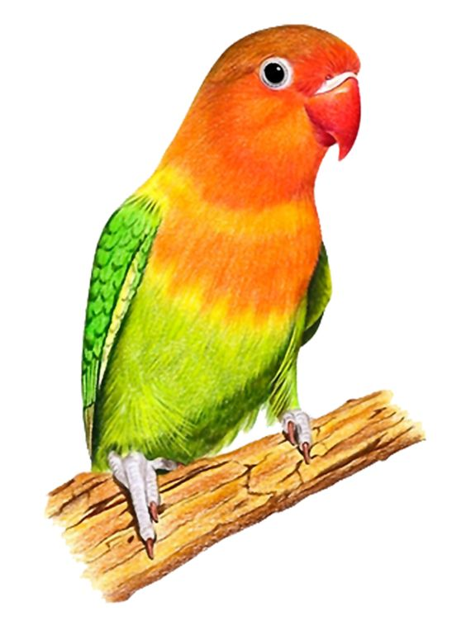
Full Membership: Annual Fee ---------------------$ 40
Pensioner: Pension Number is
required for pensioner discount ----------------- $ 30
Junior Member: (under 16 years)-----------------$ 20
Associated Member:
(other of family of full member)-------------------$ 5.00
Associated Members do not receive the ALBS Digest.
The above subscriptions include a $5.00 joining fee.

Membership Secretary - Stephen Hornby
E mail - essjh8452@hotmail.com
Phone-0407 797 997 . Online Payment is set below.
PO Box 5131, Wheeler Heights NAB- National Australia Bank
NSW 2097. (BSB-082294)--(ACC-037019450)

Please: Enter your details below to become a member.

I enclose the sum of $____________ being payable for my annual subscription to:
The African Lovebird Society of Australia Incorporated.

Mr --------- Mrs --------- Master --------- Miss --------- Ms (Please circle applicable)

First Name: ____________________ Surname _______________________________
Address: __________________________________________________________________
Suburb: _________________________ State__________ Postcode _______________
Email address: __________________________________ Phone: _________________
Date of Birth: ____________________ (Junior members only)
Pension number: __________________________ (If applicable)

Payment can be made by these methods: Online, by Cheque, or by Money order.
Payable to: The African Lovebird Society of Australia Incorporated

