The African Lovebird Society of Australia Incorporated

Thank you for considering becoming a member of our African Lovebird Society,
or as an existing member for renewing your membership.

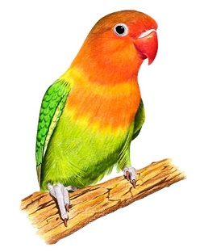
As a New / Existing Member you will receive all the following entitlements,
including: Our Bi-Monthly colour magazine ‘Agapornis Digest’
Access to purchasing the ALBS Leg Rings
Access to participating in club shows
Access to using the clubs DNA service

And access to our Sister Society The African Lovebird Society of Belgium who have
10 other Lovebird Society’s all around the world sharing their experiences with us.

Membership Subscription Details
NEW MEMBERS RENEWING MEMBERS

Full Membership: Annual Fee------------------$40 --------------------------$35
Pensioner: Pension Number is
required for pensioner discount ------------- $30 --------------------------$25
Junior Member: (under 16 years)-------------$20 --------------------------$15
Associate Member:
(A family member of full a member)----------$15 --------------------------$10

The above subscriptions include a $5.00 joining fee for new members only.
Associate Members do not receive the ‘Agapornis Digest’.

Membership Secretary - Stephen Hornby
E mail - essjh8452@hotmail.com
Phone-0407 797 997 .

All postal correspondence shall be addressed: Online Payment as set below:
David Horn – Secretary NAB- National Australia Bank
African Lovebird Society of Australia Inc. (BSB-082294)--(ACC-037019450)
P.O. Box 846
Kellyville NSW 2155.

New Members only please enter your details below.
Existing members pay via NAB , by cheque or by Money order. Mark “MEM” after name.

I enclose the sum of $____________ being payable for my annual subscription to:
The African Lovebird Society of Australia Incorporated.

Mr --------- Mrs --------- Master --------- Miss --------- Ms (Please circle applicable)
First Name: ____________________ Surname _______________________________
Address: __________________________________________________________________
Suburb: _________________________ State__________ Postcode _______________
Email address: __________________________________ Phone: _________________
Date of Birth: ____________________ (Junior members only)
Pension number: __________________________ (If applicable)

Payment can be made by these methods: Online, by Cheque, or by Money order.

